Notes on Pricing optimization

Deal discounting Groupon - (<https://www.youtube.com/watch?v=9QDOTtRxfbg&t=3774s> 21:57)

Given the new deal selected

1. Has 1 select price change over the period
2. Select previous deal with similar features (category, discount) using k clusters to create a pre observed demand hypothesis

Fast Fashion- Thompson sampling: two price example

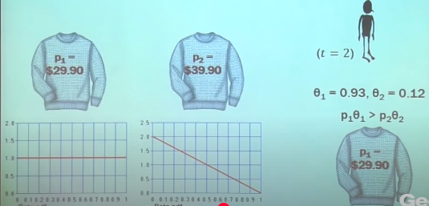

Customer would be offered two different prices and depending on the selection of the products the posterior belief will be updated and will converge on the true distribution